1. Programs in relation to the OS and Kernel
Sub-topics:
- Processes and threads
- Threading Model
- Process anatomy
- Virtual Memory
- Threads being executed on CPU, the associated scheduler & cache

Processes and threads
- A process is an independent execution unit
  - Uses only interprocess communication mechanisms
  - Processors do not share memory by default
- A thread is a separate path of execution within a process
  - Uses synchronization mechanisms for communication
  - The programmer needs to protect shared data
    - Mutex', Semaphores, conditionals etc.
      - “Thread Safety” - When multiple threads can safely access a given item at any given time
  - Shares memory

Threading Model
Three different threading models:
- User level
  - N:1 – N number user threads for 1 kernel thread
    - Only one thread being scheduled at a time
  - Simple and fast context switching
  - No kernel multi-threading – No multi-core handling
  - Kernel is unaware of user threads
- Kernel level
  - Kernel needs thread awareness
  - Kernel threads maps directly to user threads
    - 1:1 - One kernel thread for each user thread
    - Slow(er) context switching
  - Good multi-core handling
  - Used in Linux(NPTL – Native POSIX Thread Library) and Win32
- Hybrid level
  - N:M
    - N number of user threads running on M number of kernel threads(“virtual processors”)
  - Complex, requires good coordination between user- and kernel-land scheduler
  - Suboptimal resource usage
  - Used in Windows 7

Process anatomy
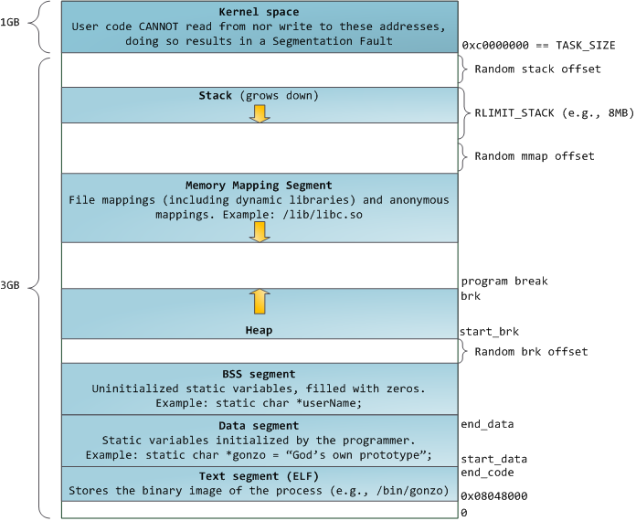

Kernel space:
- The OS resides here, user is not allowed to read or write here
- Is always there
- 1 GB
Stack:
- Contains:
  - Local variables
  - Function return values
- LIFO (Last in First Out)
Heap:
- “Free-store”
- Dynamically allocated memory
  - new and delete operators
Memory Mapping:
- File(s) mapped in memory
  - The “mmap()” function
- Dynamic linked libraries

Virtual Memory
- Each process has its own virtual memory ”block”, that is mapped to physical memory
  - A virtual memory block starts at page 1 for all processes
  - All processes think they have the same memory addresses available each time they are run, even when the physical addresses are different
- Processes do not share virtual memory(by default)
  - If shared memory is used, some pages of the virtual memory can be shared
  - Threads do
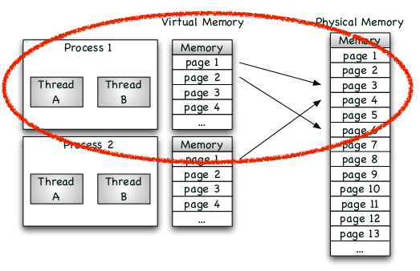

- The CPU accesses physical memory through the Memory Management Unit (MMU)
  - The MMU handles errors when trying to access illegal addresses
    - Segmentation Fault etc.

Threads being executed on CPU, the associated scheduler & cache
Cache:
- Very fast, and very close(physically) to the CPU
- Stores copies of the data from the most frequently used memory locations
- Consists of “lines”, where memory consists of “locations”
  - Sequential access for best performance
- Is prioritized over main memory
  - The CPU first checks if the requested data is in the cache, then the main memory afterwards
  - Cache hits occurs when the processor “finds” the requested memory in the cache
  - If a cache miss occurs, the cache allocates a new entry and copies data from main memory
  - Holds a certain number of bytes
  - The smallest unit of memory that can be transferred between main memory and cache
- Different levels
  - Smaller cache has lower latency but higher miss rate
  - Typically L1(smallest), L2 and L3(largest) for modern processors
    - L1 is checked first, then L2, then L3 and lastly main memory
Scheduling:
- A process is given CPU time by the scheduler according to its priority
  - Higher priority = more CPU time
- Sleeping processes get scheduled out
  - Processes that wake-up are scheduled back in after a short time
  - E.g. when a process calls “sleep()” and wakes up afterwards
- From Linux 2.6.23 and onward a “Completely Fair Scheduler” is used
  - Sleeping processes have equal priority to processes in the run-queue

